PRESS RELEASE 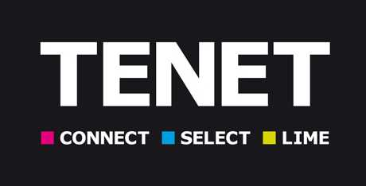

for immediate release (with picture) 27 january 2014

Scottish life voted ‘provider of
the year 2013’ by tenet advisers

Scottish Life was awarded the title ‘Provider of the Year 2013’ at Tenet Group’s January annual business conference.

Following a comprehensive survey of Tenet advisers, Scottish Life was voted as the best overall life and pensions provider in its sector for proposition and brand, with Aviva and Just Retirement taking second and third place respectively.

Eric Keenan, Scottish Life national partnerships manager who received the award on behalf of the provider commented: “We are delighted to receive the award as Tenet ‘Provider of the Year’, especially as it is voted for by advisers.”

Other provider awards on the day saw M&G taking the title of ‘Fund Manager of the Year’, for the second consecutive year, The Source Insurance named as ‘General Insurance Provider of the Year’ and Halifax named as and ‘Lender of the Year’.

Tenet Group chief executive, Martin Greenwood added: “These awards are based on the feedback from our annual provider survey conducted with our advisers. They recognise those providers judged to have the strongest propositions, excellent customer service and streamlined IT infrastructure, therefore enhancing the quality of advice delivered from advisers to consumers.”

In addition, nine individual awards were also made to Tenet firms and advisers, covering everything from the best newcomer to adviser of the year.

Ends

Picture caption: Eric Keenan (centre) receives award from Tenet Group chief executive, Martin Greenwood (right), watched by impressionist and comedian Alistair McGowan, who hosted the awards ceremony.

For further information, please contact:

Emma Bull, PR manager

Tel: 0113 239 5342

E-mail: emma.bull@tenetgroup.co.uk

David Booth, PR executive OR Helen Turner, distribution &

development director
Tel: 0113 239 5342 Tel: 0113 239 0011

E-mail: david.booth@tenetgroup.co.uk E-mail: Helen.turner@tenetgroup.co.uk

Note to editor:
Tenet Group, the Leeds-based adviser support group is one of the largest and longest established in the UK, supporting thousands of advisers across four key support propositions. Post-RDR, it aims to support advisers in the most appropriate way to suit their business model - offering an investment network, TenetConnect, a non-investment network, TenetLime, a support service provider, TenetSelect and a small national, Aspire Financial Advisers. Ranked as one of the top ten UK adviser support groups based on turnover, Tenet holds over £28m of net assets and has no external debt.

Website:
http://www.tenetgroup.co.uk



